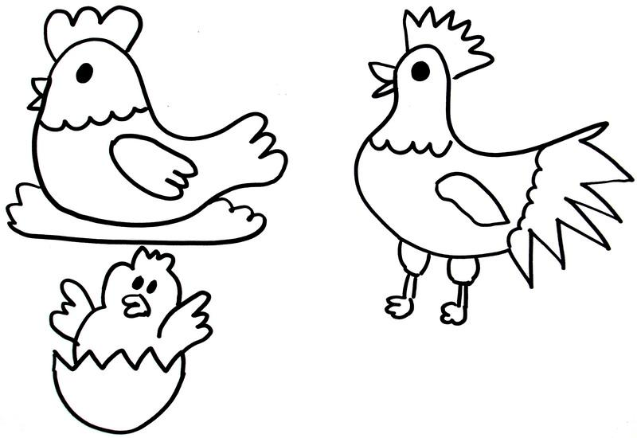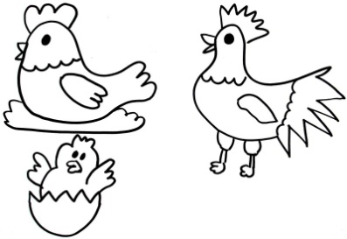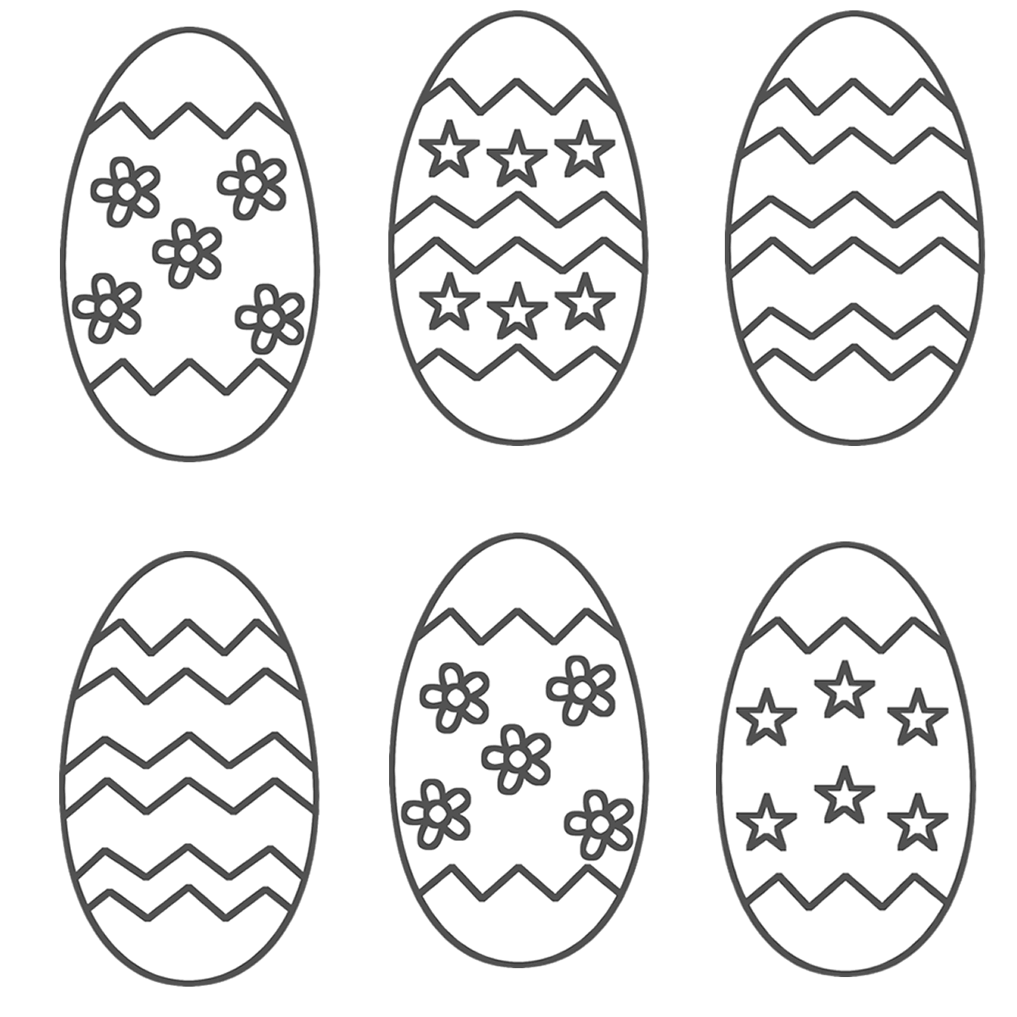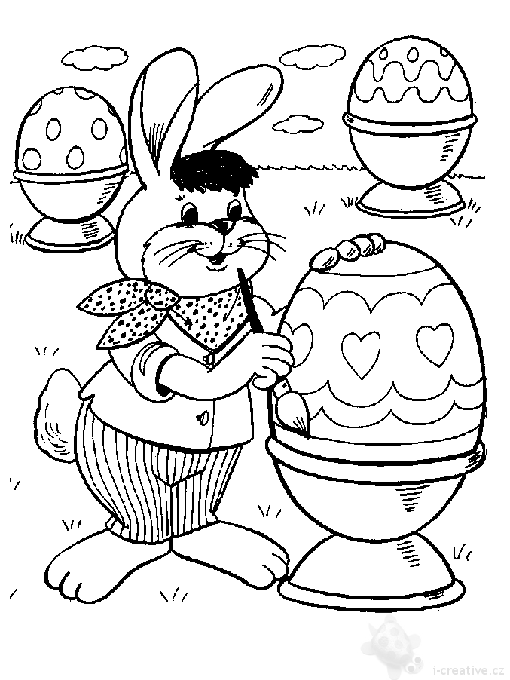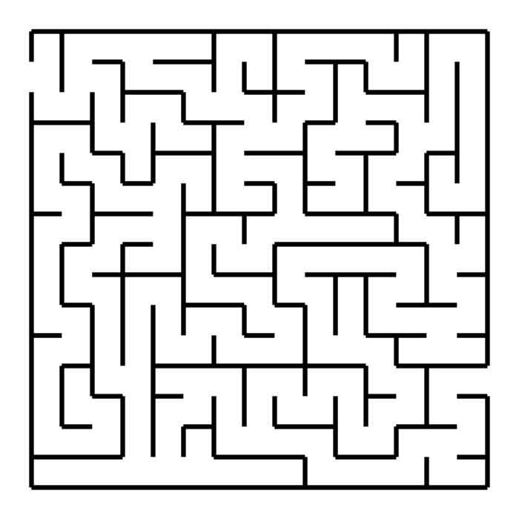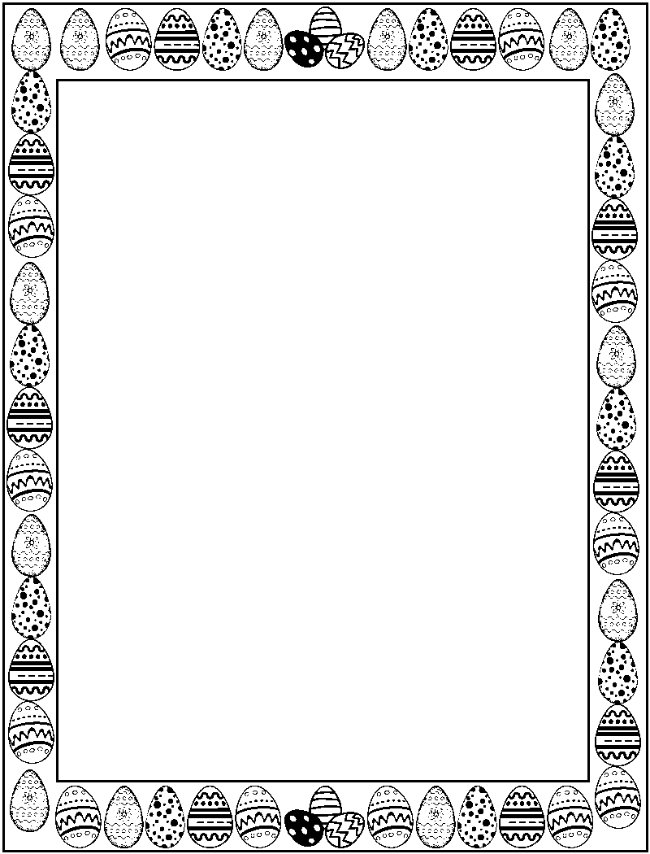

Collect the eggs and colour them:  
Egg 1- blue Egg 6- black  
Egg 2- green Egg 7- yellow  
Egg 3- red Egg 8- white  
Egg 4- orange Egg 9- purple  
Egg 5- brown Egg 10- pink